EE-213L Electric circuits Lab Lab-07
Lab 07
Impedance, Transient, and Steady State Response of Parallel RLC Circuits
Name: Muhammad Adeen Khan | Student ID: mk09201

7.1 Objective
The Objectives of this Lab are to:
• To find the impedance of the Parallel RLC Circuit and analyze its relationship with frequency.
• To find the responses (Over, critically and Underdamped) for source free Parallel RLC circuit.
7.2 Pre-Lab Task
Task 1:
Calculate the theoretical values of XC∠∅, XL∠∅ and Z∠∅ on input frequencies provided in Table 7.2. Provide all the calculations with a manual.
7.3 Introduction
In the parallel RLC circuit, the supply voltage Vin is common to all three components whilst the supply current I consist of three parts. The current flowing through the resistor, I_{R}, the current flowing through the inductor, I_{L} and the current through the capacitor, IC.
7.4 Parallel RLC Circuits
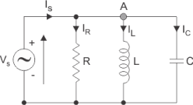
Figure 7.1: Parallel RLC Circuit
1
EE-213L Electric circuits Lab Lab-07
Formulae
^{Admittance:} _{�� =} √₍¹��)²₊ ₍1 (����₎− (����))
2
(1)
Impedance:
_{�� =}¹_{��=}1
√₍¹��)²₊ ₍1
(����₎− (����))
²(2)
�� = √��² + (���� − ����)² (3)
^{Where:} _{�� =}¹���� (����������������������) =¹��(4) ��_{�� =}¹��_{��=}¹���� ��_{�� =}¹����= ���� (5)
_{������∅ =}��_{��=}����∅ = ������⁻¹ ₍����) (6)
or
_{������∅ =}��_{��=}¹��∅ = ������⁻¹ ₍¹��) (7)
Phasor Diagram
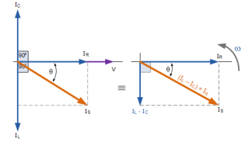
Figure 7.2
2
EE-213L Electric circuits Lab Lab-07
Task 2: To perform time domain transient analysis of parallel RLC Circuits on PSpice
1. Simulate the circuit as shown in Figure 7.1 on PSPICE¹. Keep Vin = 3 (VSIN) at 8kHz, R = 1 kΩ, L = 10mH and C = 10nF. Perform time domain transient analysis and fill Table 7.1. Measure Ic and its ∆t w.r.t Vc and I_{L} and its ∆t w.r.t VL
Table 7.1
IC | 1.5080m | IL | 5.9695m
���� | 3 | ���� | 3
∆���� | 30.821u | ∆���� | -30.893u
Φc | 88.76 | ΦL | -88.97
���� | 1989.39 | ���� | 502.55

2. According to frequencies mentioned in Table 7.3. perform AC sweep analysis and record I_{T} ∠∅, V∠∅ ������ Z∠∅. Make sure ∆t is noted with correct sign (i.e., keeping Vin as reference) it will result in correct signs for ∅. For capacitor voltage use the V(C1:2 , C1:1)
Table 7.2
Freq (Hz) | X_{C} ∠∅ | X_{C} ∠∅ | Z ∠∅
8 k
12 k
16 k
20 k
24 k
30 k

Table 7.3
Freq (Hz) | I_{T} ∠∅ | ∆�� | V∠∅ | Z∠∅
8 k | 5.3754m<-56.074 | -19.47u | 3<0 | 558.093<56.074
12 k | 3.4558m<-29.782 | -6.89u | 3<0 | 868.551<29.782

¹ When connecting an inductor in parallel use a small resistor in series.
3
EE-213L Electric circuits Lab Lab-07
16 k | 3.0003m<636m | 0.110u | 3<0 | 0.9999K<-636m
20 k | 3.3039m<24.967 | 3.47u | 3<0 | 907.774<-24.967
24 k | 3.9276m<40.36 | 4.67u | 3<0 | 763.604<-40.36
30 k | 5.0512m<53.59 | 4.96u | 3<0 | 594.015<-53.59

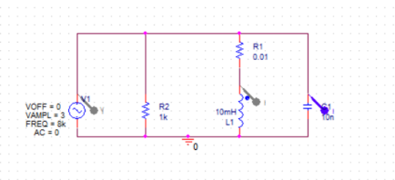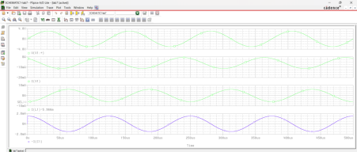
For It:
4
EE-213L Electric circuits Lab Lab-07 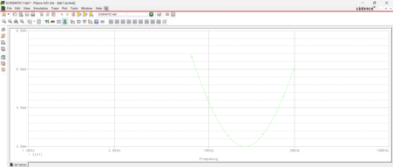
For angle of It:
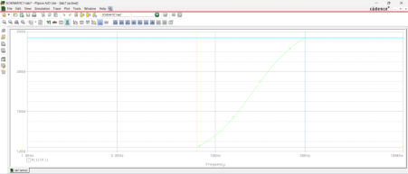For Z:
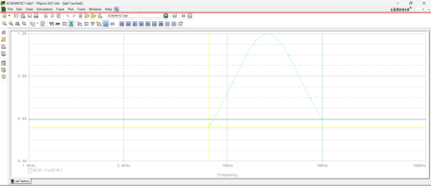For angle of Z:
5
EE-213L Electric circuits Lab Lab-07 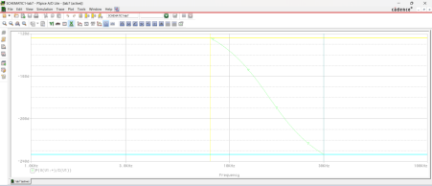
3. Attach simulation model and add plots of I_{T} ∠∅ & V∠∅ at 8kHz.
4. Comment on your observations in Table 7.2 and Table 7.3.
The current decreases as it approaches the resonant frequency (i.e. 16k), while the impedance increases and the current increases and impedance decreases when they move away from the natural frequency. At 16k the circuit becomes completely resistive.
The angles are opposite in sign of each other, where the currents phase is +ve the impedances phase is –ve and vice versa.

7.5 Parallel Resonance
Parallel resonance occurs when the supply frequency creates zero phase difference between the supply voltage and current producing a resistive circuit.
In many ways a parallel resonance circuit is exactly the same as the series resonance circuit. Both are 3-element networks that contain two reactive components making them a second-order circuit, both are influenced by variations in the supply frequency and both have a frequency point where their two reactive components cancel each other out influencing the characteristics of the circuit. Both circuits have a resonant frequency point.
The difference this time however, is that a parallel resonance circuit is influenced by the currents flowing through each parallel branch within the parallel LC tank circuit. A tank circuit is a parallel combination of L and C that is used in filter networks to either select or reject AC frequencies. Consider the parallel RLC circuit in Figure 7.1.
6
EE-213L Electric circuits Lab Lab-07
A parallel circuit containing a resistance, R, an inductance, L and a capacitance, C will produce a parallel resonance (also called anti-resonance) circuit when the resultant current through the parallel combination is in phase with the supply voltage. At resonance there will be a large circulating current between the inductor and the capacitor due to the energy of the oscillations, then parallel circuits produce current resonance.
A parallel resonant circuit stores the circuit energy in the magnetic field of the inductor and the electric field of the capacitor. This energy is constantly being transferred back and forth between the inductor and the capacitor which results in zero current and energy being drawn from the supply.
This is because the corresponding instantaneous values of IL and IC will always be equal and opposite and therefore the current drawn from the supply is the vector addition of these two currents and the current flowing in IR.
Resonance occurs when X_{L} = X_{C} and the imaginary parts of Y become zero. Then:
Notice that at resonance the parallel circuit produces the same equation as for the series resonance circuit. Therefore, it makes no difference if the inductor or capacitor are connected in parallel or series.
Also, at resonance the parallel LC tank circuit acts like an open circuit with the circuit current being determined by the resistor, R only. So, the total impedance of a parallel resonance circuit at resonance becomes just the value of the resistance in the circuit and Z = R as shown.
Task 3: To perform AC sweep analysis of Parallel RLC Circuits on PSpice
Perform AC sweep analysis on PSPICE to identify the resonant frequency point as mentioned in Figure 7.2. Attach the graphs of following parameters along with brief comment on the trend and its reason.
1. Z (magnitude) vs Frequency
2. Z (Phase) vs Frequency
3. I_{T} vs Frequency
7
EE-213L Electric circuits Lab Lab-07
Figure 7.3: Parallel resonance frequency curve
Z (Magnitude) vs Frequency:
The impedance increases as it approaches the resonant frequency (i.e. 16k) and decreases when it goes away from the resonant frequency the impedance is the highest at 16k because the circuit becomes completely resistive.

Z (Phase) vs Frequency

8
EE-213L Electric circuits Lab Lab-07
The angle starts out positive and keeps on decreasing as the frequency increases

I_{T} vs Frequency
The current decreases as it approaches the resonant frequency (i.e. 16k) and increases when it goes away from the resonant frequency the current is the least at 16k because the circuit becomes completely resistive.

9
EE-213L Electric circuits Lab Lab-07
7.5 Source Free Parallel RLC Circuits
Figure 7.4: Parallel RLC circuit for t > 0
Consider the parallel RLC circuit shown in Error! Reference source not found. Figure 7.4. Assume i nitial inductor current and initial capacitor voltage,
0
��(0) = ��₀ ₌¹��∫ ��(��)����
∞
��(0) = ��₀
Since the three elements are in parallel, they have the same voltage �� across them. According to passive sign convention, the current is entering each element; that is, the current through each element is leaving the top node. Thus, applying KCL at the top node gives
��₀
_{��+}¹��∫ �� ����
��
��
_{+ C}����
���� = 0
Taking the derivative with respect to t and dividing by C results in
��²��
��²_{��+}¹��������
_{���� +}¹���� �� = 0
Characteristic Equation is given by
��² ₊¹_{���� �� +}¹����
Roots of the equation are given by
��_{1,2} = −�� ± √��² − ��₀2
where,
10
EE-213L Electric circuits Lab Lab-07
_{�� =}1  2���� | Damping Factor
��₀ = √¹���� | Resonant Frequency
���� = √��₀² − ��² | Damping Frequency

The solution to above equation has two components: the transient response and the steady-state response that is,
��(��) = ����(��) + ������(��)
The steady-state response is the final value of ��(��)
������(��) = ��(∞)
The transient response for the overdamped, underdamped, and critically damped cases are
����(��) = ��₁����₁�� + ��₂����₂�� | (Overdamped) | �� > ���� | �� > 4��²��
����(��) = (��₁ + ��₂��)��^{−����} | (Critically damped) | �� = ���� | �� = 4��²��
����(��) = (��₁������������ + ��₂������������)��^{−����} | (Underdamped) | �� < ���� | �� < 4��²��

Task 4: To determine resistor values that would lead to overdamped, underdamped, and critically damped responses.
1. Calculate the �� and ���� values and state the response type of circuit shown in Figure 7.4.
�� | 1.2
���� | 4.89
���������������� �������� | underdamped

2. Initial Conditions for Capacitor and Inductor are: vC(0-) = 97.30 V and iL(0-) = 2.027 A. Since neither quantity can change in zero time, vC(0+) = 97.30 V and iL(0+) = 2.027 A. 3. Verify the response simulating and plotting iL(t) of given circuit. Remember to define initial conditions values (IC) by double clicking on Capacitor or Inductor symbol in PSPICE. 4. Attach the simulation model and the plots.
5. Change the resistance value to match criteria for other two types of responses. Attach calculation below.
11
EE-213L Electric circuits Lab Lab-07
12
EE-213L Electric circuits Lab Lab-07
Calculation:

13
EE-213L Electric circuits Lab Lab-07

6. Plot iL(t) to achieve Overdamped, Critically and Underdamped responses in single figure. Refer Figure 7.5. Also attach the plot.
14
EE-213L Electric circuits Lab Lab-07
Figure 7.5: Simulated response for three different resistance values (Reference figure).
Red = underdamped, Blue = critically damped, Green = overdamped
15
EE-213L Electric circuits Lab Lab-07 16
EE-213L Electric circuits Lab Lab-07
Assessment Rubric
Lab 07
Impedance, Transient, and Steady State Response of Parallel RLC Circuits
Name: | Student ID:

Points Distribution
Task No. | LR 2  Simulation | LR 4  Data Collection | LR5  Results/Plots | LR6  Calculation | LR 10  Analysis
Task 1 | /- | /- | /- | /10 | /-
Task 2 | /5 | /15 | /10 | /- | /-
Task 3 | /- | /- | /10 | /- | /10
Task 4 | /- | /- | /10 | /10 | /-
Total | /5 | /15 | /30 | /20 | /10
CLO  Mapped | CLO 2 | CLO 2 | CLO 2 | CLO 2 | CLO 2

Affective Domain Rubric |  | Points | CLO  Mapped
AR 7 | Report Submission (Pre-Lab + Post Lab) | /(5+5) | CLO 4

CLO | Total Points | Points Obtained
2 | 90
4 | 10
Total | 100

For description of different levels of the mapped rubrics, please refer the provided Lab Evaluation Assessment Rubrics and Affective Domain Assessment Rubrics.
17
EE-213L Electric circuits Lab Lab-07
Lab Evaluation Assessment Rubric
# | Assessment  Elements | Level 1: Unsatisfactory  Points 0-1 | Level 2: Developing  Points 2 | Level 3:Good  Points 3 | Level 4:Exemplary  Points 4
LR1 | Circuit Layout | Connections between circuit components are mostly wrong. Circuit layout is cluttered. Needs guidance to make correct equipment/ component connections. | Few of the connections made between circuit components are wrong. Circuit layout is not neat and clean as per standards. | Circuit layout and connections are correct but not all connections are neat and clean as per standards. | Neat, clean and correct connections of all the circuit components/ equipment are made as per standard circuit diagram.
LR2 | Program/Code/ Simulation Model/ Network Model | Program/code/simulation  model/network model does not implement the required functionality and has several errors. The student is not able to utilize even the basic tools of the software. | Program/code/simulation model/network model has some errors and does not produce completely accurate results. Student has limited command on the basic tools of the software. | Program/code/simulation  model/network model gives correct output but not efficiently implemented or implemented by computationally complex routine. | Program/code/simulation /network model is efficiently implemented and gives correct output. Student has full command on the basic tools of the software.
LR3 | Troubleshooting | Unable to identify the fault/minimal effort show in troubleshooting. | Able to identify the fault but unable to remove it. | Able to identify the fault but partially removes it. | Able to identify the fault and takes necessary steps and actions to correct it.
LR4 | Data Collection | Measurements are incomplete, inaccurate and imprecise. Observations are incomplete or not included. Symbols, units and significant figures are not included. | Measurements are somewhat inaccurate and imprecise. Observations are incomplete or vague. Major errors are there in using symbols, units and significant digits. | Measurements are mostly accurate. Observations are generally complete. Minor errors are present in using symbols, units and significant digits. | Measurements are both accurate and precise. Data collection is systematic. Observations are very thorough and include appropriate symbols, units and significant digits and task completed in due time.
LR5 | Results & Plots | Figures/ graphs / tables are not developed or are poorly constructed with erroneous results. Titles, captions, units are not mentioned. Data is presented in an obscure manner. | Figures, graphs and tables are drawn but contain errors. Titles, captions, units are not accurate. Data presentation is not too clear. | All figures, graphs, tables are correctly drawn but contain minor errors or some of the details are missing. | Figures / graphs / tables are correctly drawn and appropriate titles/captions and proper units are mentioned. Data presentation is systematic.
LR6 | Calculations | Formulae used and/or calculations are incorrect. Units are not mentioned with results. | Formulae used are correct but there are few mistakes in calculation which lead to incorrect results. | Formulae used and end results are correct. Complete working steps are not shown. Proper units are not mentioned with results. | Formulae used, end results and all calculations are correct with all the intermediate steps clearly shown. Units are mentioned with results.
LR9 | Report | All the in-lab tasks are not included in report and / or the report is submitted too late. | Most of the tasks are included in report but are not well explained. All the necessary figures / plots are not included. Report is submitted after due date. | Good summary of most the in-lab tasks is included in report. The work is supported by figures and plots with explanations. The report is submitted timely. | Detailed summary of the in-lab tasks is provided. All tasks are included and explained well. Data is presented clearly including all the necessary figures, plots and tables.
LR10 | Analysis | Results are not interpreted or are analyzed incorrectly. | Analysis of the obtained results is incomplete. Conclusions are not drawn. | Results are analyzed and concluded but are not well explained and justification is not provided with the help of reasoning. | Results are well analyzed supported with reasons. Good comparison is made between the theoretical and experimental results with correct and useful conclusion.
LR11 | Design | Proposed design is unsubstantiated or does not satisfy most of given constraints. The breakdown of system into features is incomplete and still at lower resolution. | Justification for proposed design is weak, and it only satisfies some constraints. The breakdown of system is missing some features and resolution is not appropriate at some places. | Proposed design is substantiated, preferably through proper analysis, and satisfies most given constraints. The breakdown of system into features seems complete, but resolution is not appropriate at some places. | Proposed design is substantiated, preferably through proper analysis, and satisfies all given constraints. The breakdown of system into features seems complete and at appropriate resolution, given students' level.

18

